AI-POWERED CYBERSECURITY ASSISTANT
An Intelligent, Chatbot-Driven Threat Detection & Response System

A Major Project Report
Submitted in partial fulfillment of the requirements for the award of the degree of
[Masters of Computer Application]

Submitted by
Ansh Patel

Under the Guidance of
[Guide / Mentor Name]

[Department of Masters of Computer Application]
Academic Year 2026–2027

ABSTRACT
Cyberattacks have grown faster, more automated, and harder to detect than the manual workflows most individuals and small teams rely on, leaving a widening gap between the volume of daily threats — phishing emails, malicious files, suspicious network activity — and the human attention available to triage them. This project proposes an AI-Powered Cybersecurity Assistant: a conversational, AI/ML-driven system that helps users identify, understand, and respond to common cyber threats in real time. Rather than building the entire system at once, the project is planned as four incremental versions of increasing capability. Version 1 delivers a basic assistant that combines a phishing email/URL classifier with a security-focused chatbot. Later versions layer on malware file analysis, network/log-based intrusion detection, and finally a unified, dashboard-driven assistant that correlates signals across all modules and suggests remediation steps. The system combines classical machine learning (Random Forest, XGBoost), natural language processing (transformer-based text classification and an LLM-backed conversational engine), and established cybersecurity tooling (YARA, VirusTotal, Suricata-style network analysis) into a single assistant accessible through a chat interface. This report documents the background and motivation, system architecture, working, technology stack, requirements, phased roadmap, implementation approach, testing strategy, and future scope of the project.

TABLE OF CONTENTS
Abstract 3
1. Introduction 5
2. Objectives of the Project 6
3. Literature Review / Existing Systems 6
4. Scope of the Project 7
5. System Architecture 8
6. Working / Methodology 10
7. Technology Stack & Tools 12
8. Version-Wise Development Roadmap 13
9. Requirements 15
10. Project Timeline 17
11. Implementation Details 18
12. Testing Strategy 18
13. Expected Results / Sample Interaction 20
14. Advantages of the Proposed System 20
15. Limitations & Challenges 20
16. Future Scope 21
17. Conclusion 21
18. References 22

1. Introduction

1.1 Background
The digital ecosystem that individuals, students, and organizations depend on today is under constant threat from a rapidly evolving landscape of cyberattacks. Phishing emails imitate trusted senders to steal credentials, malicious attachments and downloads carry malware that can encrypt or exfiltrate data, and network intrusions probe systems for exploitable weaknesses around the clock. Traditional defenses — signature-based antivirus software, static firewall rules, and manually maintained blocklists — are effective against known threats but struggle against novel or slightly-modified attacks, and they rarely explain themselves in language a non-expert user can act on. At the same time, dedicated Security Operations Centers (SOCs) with trained analysts are expensive and out of reach for most students, freelancers, and small organizations, leaving them to self-diagnose suspicious emails, files, and system behaviour with no expert guidance.
Artificial Intelligence, and Machine Learning in particular, has demonstrated strong results in exactly this kind of pattern-recognition problem: classifying text as phishing or legitimate, flagging anomalous network traffic, and recognizing the structural fingerprints of malicious files. Combined with the recent maturity of conversational AI (large language models capable of understanding natural-language questions and holding context across a conversation), it is now practical to package these detection capabilities behind a chat-style assistant that a non-expert can simply talk to — "Is this email safe?", "Scan this file", "What does this alert mean?" — instead of operating disconnected security tools.

1.2 Problem Statement
Most individual users and small teams lack an accessible, unified, and intelligent way to (a) verify whether a given email, link, or file is malicious, (b) understand unusual activity on their network or system logs, and (c) receive plain-language guidance on how to respond — without paying for enterprise security suites or possessing specialized cybersecurity training. Existing point tools (antivirus scanners, spam filters, IDS appliances) work in isolation, expose results in technical jargon, and require the user to already know which tool to reach for. There is a need for a single AI-powered assistant that consolidates detection, explanation, and guidance into one conversational interface, and that can grow in capability over time rather than requiring a complete, all-at-once enterprise deployment.

1.3 Motivation for the Project
This project is motivated by three observations. First, the volume and sophistication of cyberattacks (particularly phishing and social-engineering-driven attacks) continue to rise faster than manual triage capacity. Second, AI/ML techniques for phishing detection, malware classification, and network anomaly detection are individually well-studied and have publicly available datasets and benchmarks, making them tractable for an academic project to implement and evaluate. Third, conversational AI interfaces lower the barrier for non-expert users to interact with security tooling, turning a set of disconnected scanners into a single assistant that explains results and recommends next steps. Building this system in incremental, testable versions (rather than one large system) also mirrors real-world agile security-product development and keeps each version demonstrable and independently evaluable.

2. Objectives of the Project
The project aims to design, implement, and evaluate an AI-powered cybersecurity assistant with the following specific objectives:
- Design a conversational assistant that can answer general cybersecurity questions and route specialized requests (scan an email, scan a file, explain an alert) to the correct AI/ML detection module.
- Build an accurate phishing/email/URL classifier using NLP and machine learning to flag malicious links and messages with a measurable precision/recall trade-off.
- Build a file/malware analysis module that combines static feature analysis with signature (YARA) and reputation-based checks (e.g., VirusTotal) to assess file risk.
- Build a network/log anomaly detection module capable of flagging unusual traffic or log patterns using unsupervised and supervised ML on public intrusion-detection datasets.
- Provide plain-language explanations and remediation suggestions for every detection result, rather than a raw score alone.
- Design the system as a phased, version-wise roadmap (V1–V4) so that a working, demonstrable assistant exists at every stage, with each version adding a new capability.
- Evaluate the system using standard ML metrics (accuracy, precision, recall, F1-score, false-positive rate) and functional/usability testing of the assistant end-to-end.

3. Literature Review / Existing Systems
Before finalizing the design, comparable academic approaches and industry tools were reviewed to identify proven techniques and gaps this project can address.

3.1 Academic and Technique-Level Review
- Phishing detection: Numerous studies apply ML classifiers (Random Forest, SVM, XGBoost) and NLP text-embedding techniques to URL and email-header/body features, consistently reporting 90%+ accuracy on public phishing corpora (e.g., PhishTank, Nazario phishing corpus) when combining lexical, host-based, and content features.
- Malware classification: Static analysis using PE-header features, opcode n-grams, and API-call sequences, combined with gradient-boosted trees or deep neural networks (as in the EMBER benchmark), is a well-established approach for detecting malware without executing the file.
- Network intrusion detection: Benchmark datasets such as NSL-KDD and CICIDS2017/2018 are widely used to train supervised classifiers and unsupervised anomaly detectors (Isolation Forest, Autoencoders) for flagging DoS, probing, and botnet-style traffic.
- Conversational security assistants: Recent literature and industry white papers describe LLM-based assistants that translate raw alerts/logs into natural-language summaries, reducing analyst triage time — a pattern this project adopts at a smaller, individual-user scale.

3.2 Comparable Industry Tools
Tool / Product | What it does | Gap for an individual / student user
Traditional antivirus (e.g., signature scanners) | Detects known malware via signatures | Weak against novel/obfuscated threats; no conversational explanation
Enterprise SIEM (e.g., Splunk, QRadar) | Aggregates and correlates logs at scale | Expensive, complex, built for SOC teams, not individuals
Microsoft Security Copilot / CrowdStrike Charlotte AI | LLM-assisted enterprise threat analysis | Enterprise-licensed, tied to specific security platforms
Darktrace Cyber AI Analyst | Unsupervised ML for network anomaly detection | Enterprise network appliance, high cost, not self-serve
Standalone phishing checkers / browser plugins | Single-purpose URL reputation checks | No file/network coverage, no conversational guidance

The reviewed literature confirms that the individual detection techniques (phishing NLP classifiers, malware static analysis, network anomaly detection) are mature and reproducible with public datasets, but that no low-cost, unified, conversational assistant integrates all three for individual or small-team use — this is the gap the proposed system targets.

4. Scope of the Project

4.1 In Scope
- Text/URL-based phishing and social-engineering message detection.
- File-based malware triage using static analysis and reputation lookups (no live malware execution/sandboxing on the user's own machine).
- Network traffic and system-log anomaly detection using publicly available datasets and, where feasible, live packet capture in a controlled lab/VM environment.
- A conversational chatbot interface (web-based) that routes user requests to the correct detection module and explains results in plain language.
- A phased build across four versions (V1–V4), each independently functional and testable.

4.2 Out of Scope (for the academic implementation)
- Fully automated, unsupervised incident response (auto-blocking, auto-quarantine) on production/enterprise networks.
- Zero-day exploit discovery or offensive security testing.
- Legal/forensic-grade chain-of-custody evidence handling.
- Large-scale, multi-tenant enterprise deployment (the project targets an individual/small-team scale demonstration).

4.3 Target Users
Students and academic evaluators (as a demonstrable project), individual users and freelancers who want a first line of defense against phishing and malware without enterprise tooling, and small teams or student clubs managing their own systems without a dedicated security team.

5. System Architecture
The assistant is designed as a layered architecture so that new detection modules (the version-wise roadmap in Section 8) can be added without redesigning the user interface or data layer. Figure 1 shows the high-level architecture.
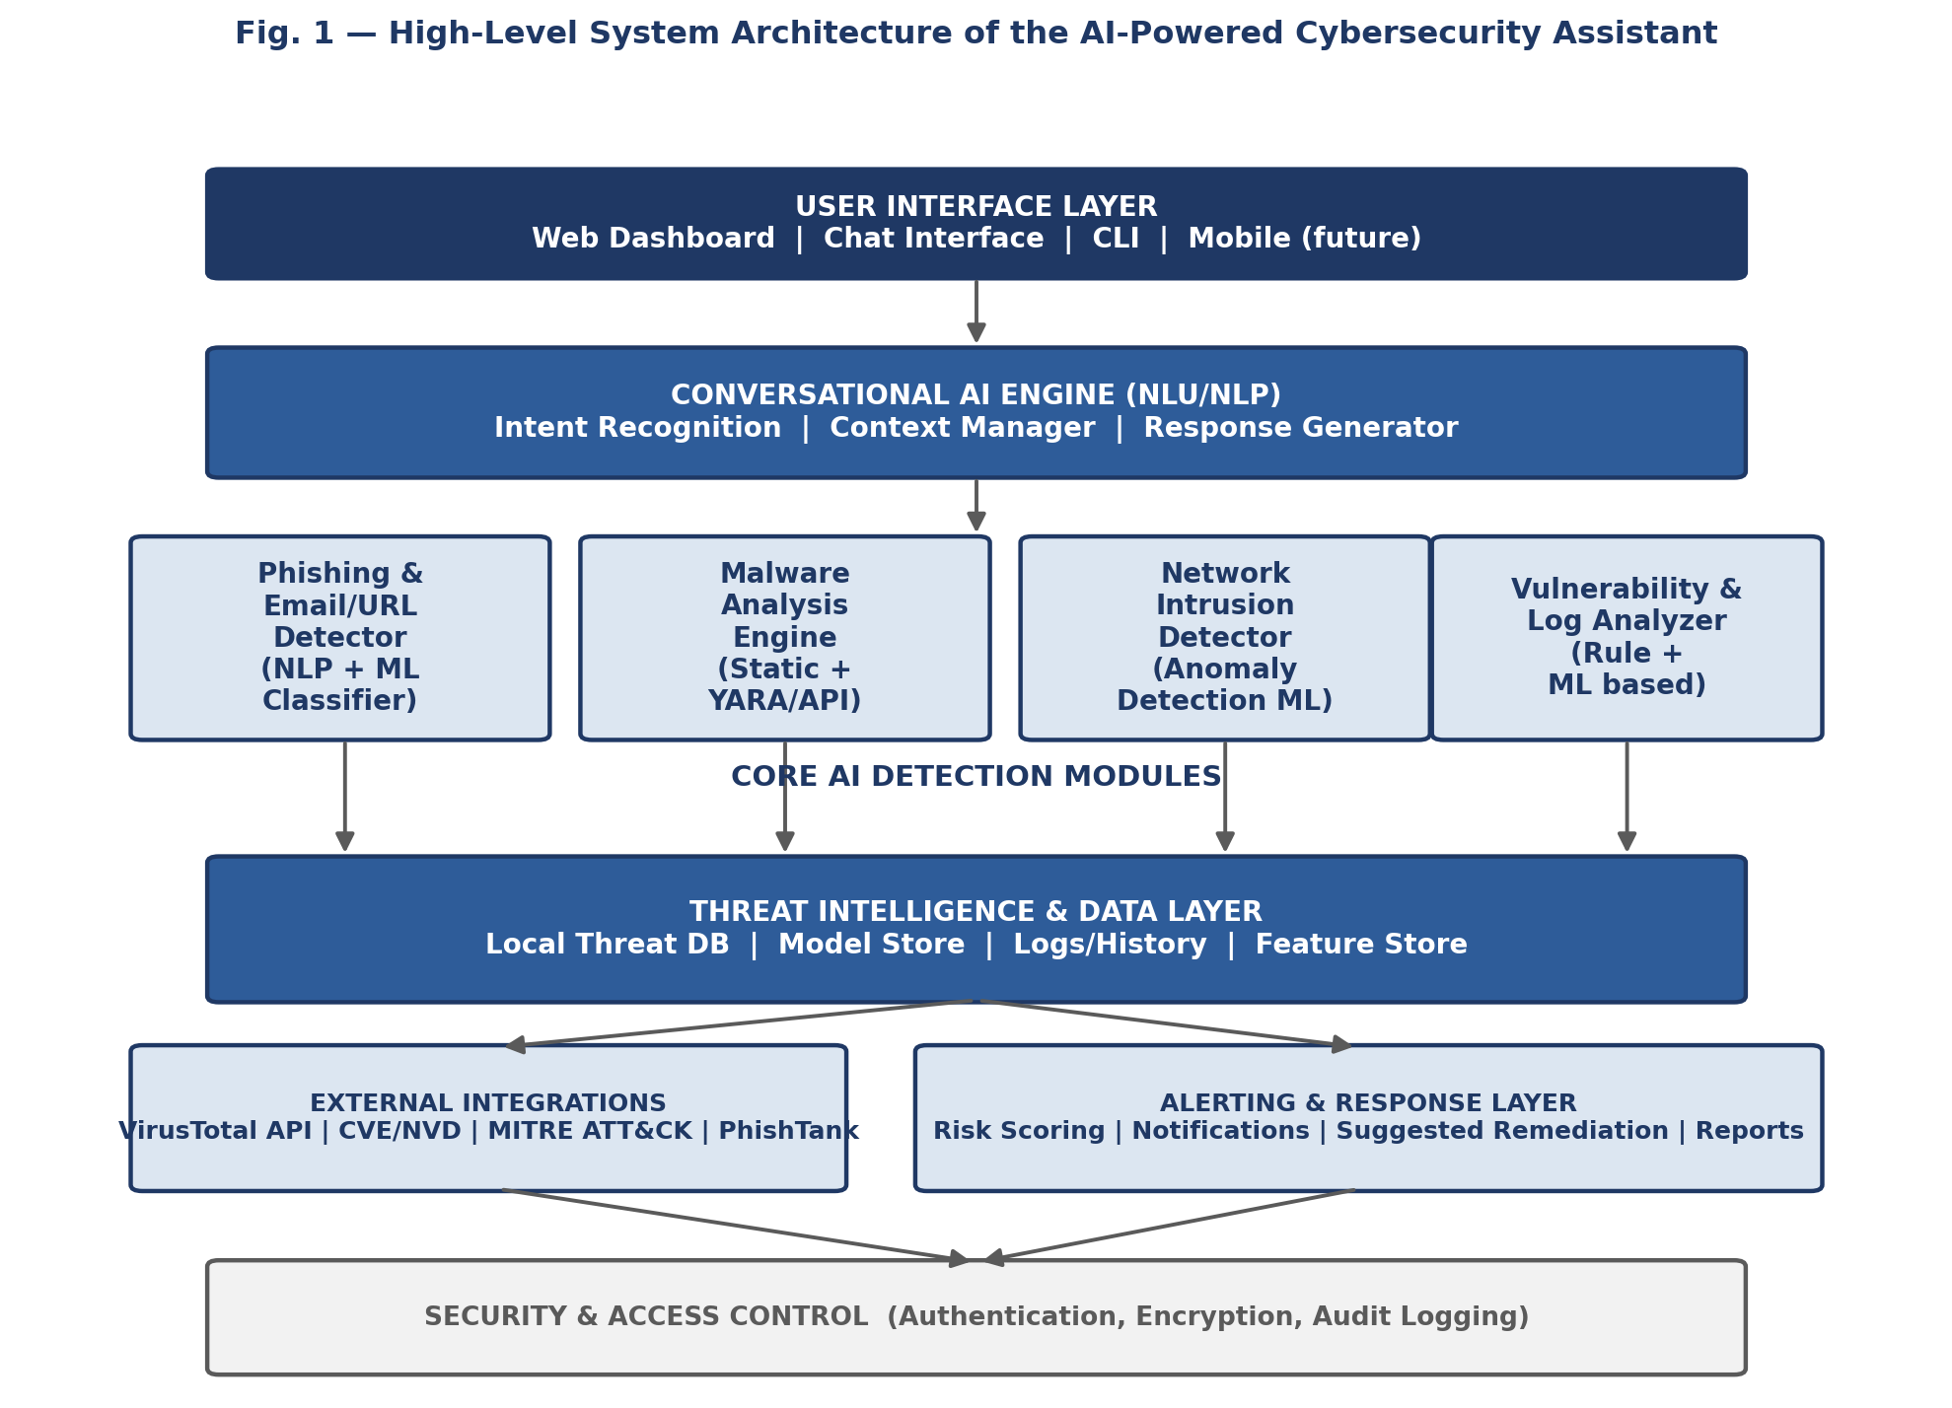
Fig. 1 — High-level system architecture of the AI-Powered Cybersecurity Assistant.

5.1 Layer Descriptions
- User Interface Layer: A web dashboard and chat widget (with a CLI available for developers/testers) through which the user submits queries, emails, URLs, files, or asks general security questions.
- Conversational AI Engine: Performs intent recognition (e.g., "scan this file" vs. "is this link safe" vs. "explain this term"), maintains conversation context, and generates natural-language responses using either a fine-tuned intent classifier (V1) or an LLM-backed engine with retrieval over security knowledge (V2+).
- Core AI Detection Modules: Four independent, pluggable modules — the Phishing & Email/URL Detector, Malware Analysis Engine, Network Intrusion Detector, and Vulnerability/Log Analyzer — each exposing a common request/response interface so the conversational engine can call any of them uniformly.
- Threat Intelligence & Data Layer: Stores the local threat database, trained model artifacts, historical scan logs, and engineered feature caches used by the detection modules.
- External Integrations: Read-only calls to public threat-intel sources — VirusTotal (file/URL reputation), the CVE/NVD database (known vulnerabilities), the MITRE ATT&CK framework (technique mapping for detected threats), and PhishTank (known phishing URLs).
- Alerting & Response Layer: Converts raw model output into a risk score, a plain-language explanation, and a suggested remediation action, and (from V3 onward) can dispatch notifications.
- Security & Access Control: Cross-cutting authentication, encrypted storage of scanned content/logs, and audit logging of every scan/query performed.

6. Working / Methodology
Figure 2 traces what happens to a single user request — a pasted email, an uploaded file, a URL, or a log snippet — as it moves through the system.
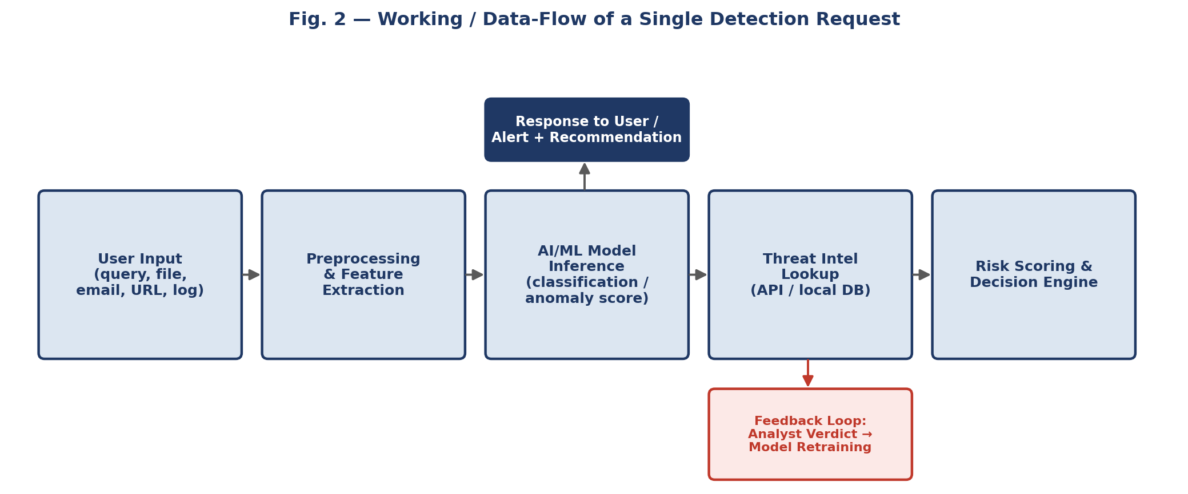
Fig. 2 — Working / data-flow of a single detection request.

6.1 Step-by-Step Working
- User Input: The user submits content through the chat interface — text of a suspicious email, a URL, an uploaded file, or a pasted log entry — or simply asks a security question.
- Preprocessing & Feature Extraction: Text is cleaned and tokenized (for phishing/NLP); files are parsed for static features such as header metadata, hash values, and (where applicable) opcode/API-call patterns; logs/network data are parsed into structured flow-level features (packet counts, byte rates, protocol flags, session duration).
- AI/ML Model Inference: The relevant trained model (classifier or anomaly detector) scores the input — e.g., a phishing-probability score from the text classifier, a malicious-probability score from the file classifier, or an anomaly score from the network model.
- Threat Intelligence Lookup: Where applicable, the system cross-checks the input against external sources (file/URL hash reputation via VirusTotal, known-phishing URL lists, CVE identifiers) to corroborate or adjust the model's score.
- Risk Scoring & Decision Engine: Model output and threat-intel corroboration are combined into a single risk level (Safe / Suspicious / Malicious) with a confidence value.
- Response to User: The conversational engine converts the risk level and contributing factors into a plain-language explanation plus a recommended action (e.g., "do not click this link — it mimics a known banking domain and was flagged by 12/70 antivirus engines").
- Feedback Loop: The user (or, in later versions, an analyst) can confirm or correct the verdict; confirmed labels are logged and periodically used to retrain/fine-tune the models, improving accuracy over time.

6.2 Working of Each Detection Module

6.2.1 Phishing & Email/URL Detector
Combines lexical URL features (domain age proxy, presence of IP-literal hosts, suspicious subdomains, use of URL shorteners) with NLP analysis of email/message body text (urgency language, spoofed sender patterns, embedded-link mismatch) and feeds them into a classical ML classifier (Logistic Regression baseline, upgraded to Random Forest/XGBoost) or a fine-tuned lightweight transformer for higher accuracy in later versions.

6.2.2 Malware Analysis Engine
For an uploaded file, the engine computes cryptographic hashes and checks them against VirusTotal and local reputation caches, runs YARA rule matching for known malicious patterns, and extracts static structural features (file type, entropy, embedded strings, PE header fields for Windows executables) that feed a supervised classifier trained on labeled malicious/benign samples. No files are executed — this is static analysis only, avoiding the need for a sandboxed execution environment.

6.2.3 Network Intrusion Detector
Parses network flow/log data into standard intrusion-detection feature sets (as used in NSL-KDD/CICIDS) — protocol type, service, byte counts, connection duration, error rates — and applies both a supervised classifier (trained to recognize known attack categories: DoS, probe, R2L, U2R) and an unsupervised anomaly detector (Isolation Forest/Autoencoder) to flag traffic that does not match any known-benign pattern, even if it does not match a known attack signature either.

6.2.4 Vulnerability & Log Analyzer
Scans structured/unstructured log entries for indicators of compromise, correlates software/service versions mentioned in logs or user queries against the CVE/NVD database, and maps detected techniques to the MITRE ATT&CK framework so the explanation given to the user references a recognized threat classification rather than an opaque internal label.

7. Technology Stack & Tools
The stack favors mature, well-documented, and mostly open-source tools so the project remains reproducible without enterprise licensing.
Category | Tools / Technologies | Purpose
Programming Languages | Python 3.x, JavaScript (ES6+) | Core AI/ML logic and backend (Python); dashboard frontend (JavaScript)
ML / DL Frameworks | scikit-learn, TensorFlow / Keras, PyTorch | Training and serving classical ML and deep-learning models
NLP Libraries | spaCy, NLTK, Hugging Face Transformers (DistilBERT/BERT) | Text preprocessing and phishing/email text classification
Conversational AI | Rasa (intent/dialogue) or LangChain + an LLM API (e.g., Claude API) | Chatbot NLU, context management, and natural-language responses
Cybersecurity Tooling | YARA, ClamAV, Scapy, Suricata (rules engine), Wireshark/tshark | Signature matching, packet capture/parsing, network rule evaluation
Threat-Intel APIs | VirusTotal API, PhishTank, AbuseIPDB, NVD/CVE API, MITRE ATT&CK | External reputation lookups and vulnerability/technique mapping
Backend Framework | Flask or FastAPI (REST API) | Serving models and orchestrating module calls
Database | SQLite (development), PostgreSQL or MongoDB (later versions) | Storing logs, scan history, user data, feature caches
Frontend | React.js, Tailwind CSS, Chart.js / Recharts | Web dashboard, chat UI, visual analytics
Datasets | PhishTank corpus, Nazario phishing corpus, UCI Spambase, CICIDS2017/2018, NSL-KDD, EMBER (malware) | Model training and benchmarking
DevOps / Tooling | Git & GitHub, Docker, GitHub Actions (CI/CD) | Version control, containerized deployment, automated testing
IDE / Utilities | VS Code, Jupyter Notebook, Postman, draw.io | Development, experimentation, API testing, diagramming
Deployment | Docker containers on AWS/Azure free tier or Render/Heroku | Hosting the demo instance of the assistant

8. Version-Wise Development Roadmap
Rather than building every capability at once, the project is planned as four incremental versions. Version 1 is deliberately scoped to "basic but complete" — a working assistant that can already demonstrate the core idea end-to-end — with each later version adding a fully new detection capability and integrating it into the same conversational interface. This keeps the project demonstrable at every milestone and lets later versions be scoped, or reprioritized, based on how much time remains.
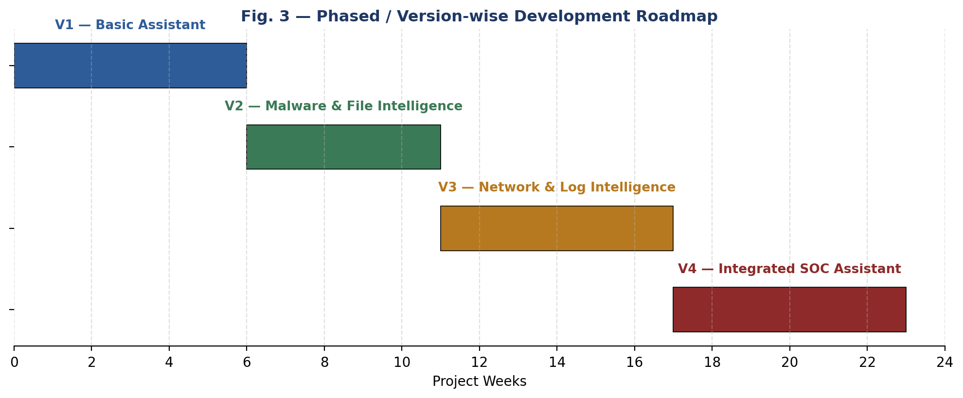
Fig. 3 — Phased / version-wise development roadmap (durations are indicative and can be compressed to fit an academic semester).
Version | Focus | Key Features Added | Indicative Duration
V1 — Basic Assistant | Foundational chatbot + phishing detection | Rule/ML-based phishing email & URL classifier; password-strength checker; chatbot for general security Q&A; simple web/CLI interface; local scan-history logging. | Weeks 1–6
V2 — Malware & File Intelligence | File-level threat analysis | File upload & static malware scanning (hashing, YARA rules); VirusTotal reputation lookups; chatbot gains conversational memory/context; basic user authentication; downloadable scan reports (PDF). | Weeks 7–11
V3 — Network & Log Intelligence | Network/system-level threat analysis | Network traffic/log anomaly detection (supervised + unsupervised ML); live packet-capture module (lab/VM); dashboard visualizations (Chart.js); email/console alerting; CVE & MITRE ATT&CK mapping. | Weeks 12–17
V4 — Integrated SOC Assistant | Unified, correlated assistant | Single dashboard correlating all modules; automated remediation-suggestion "playbooks"; multi-user role-based access; optional voice interface; continuous learning from analyst feedback; cloud deployment. | Weeks 18–23

This report documents the full design so that Version 1 can be implemented first; Sections 11 ("Implementation Details") and 12 ("Testing Strategy") apply the same pattern to each subsequent version as it is built.

9. Requirements

9.1 Functional Requirements
- The system shall accept text, URLs, uploaded files, and pasted log/network data as input.
- The system shall classify submitted email/URL text as phishing or legitimate with a confidence score.
- The system shall analyze uploaded files statically and return a risk classification without executing the file.
- The system shall flag anomalous network/log activity and categorize it where possible (e.g., DoS, probe).
- The system shall provide a conversational interface capable of answering general cybersecurity questions.
- The system shall explain every detection result in plain language and suggest a remediation action.
- The system shall log every scan/query with a timestamp for later review by the user.
- The system shall allow the user to confirm or dispute a verdict, storing the feedback for retraining.

9.2 Non-Functional Requirements
Attribute | Requirement
Performance | A single text/URL scan should return a verdict within 2–3 seconds under normal load; file scans within 10 seconds for files under 20 MB.
Scalability | The modular architecture should allow new detection modules or additional models to be added without redesigning the interface layer.
Usability | Non-expert users should be able to get a useful answer using natural language, without needing to know which module handles their request.
Security | All uploaded content, scan history, and user data must be encrypted at rest and in transit; the platform must never execute uploaded files.
Reliability | The system should degrade gracefully (e.g., fall back to local model output) if an external threat-intel API is unavailable.
Portability | The system should be containerized (Docker) so it can be deployed on any major cloud provider or run locally.
Maintainability | Detection models should be retrainable/replaceable independently of the conversational engine and UI.

9.3 Hardware Requirements
Environment | Minimum Specification
Development machine | Quad-core CPU, 8 GB RAM, 20 GB free storage (16 GB RAM recommended for local deep-learning experiments)
GPU (optional) | A CUDA-capable GPU (e.g., 4 GB+ VRAM) speeds up transformer/deep-learning model training but is not mandatory — cloud notebook GPUs (Colab/Kaggle) can substitute
Deployment server | 2 vCPUs, 4 GB RAM minimum for V1–V2; 4 vCPUs, 8 GB RAM recommended from V3 onward (network analysis is more resource-intensive)
Network capture (V3+) | A machine/VM with a network interface in promiscuous/monitor mode for live packet capture (lab environment only)

9.4 Software Requirements
Component | Requirement
Operating System | Windows 10/11, Ubuntu 20.04+/22.04+, or macOS 12+ (development); Linux recommended for the deployment server
Runtime | Python 3.10+, Node.js 18+ (for the frontend build)
Core Libraries | scikit-learn, TensorFlow/PyTorch, spaCy/NLTK, Hugging Face Transformers, Flask/FastAPI
Security Tools | YARA, ClamAV, Wireshark/tshark, Suricata (for V3 network module)
Database | SQLite (development) / PostgreSQL or MongoDB (deployment)
Containerization | Docker & Docker Compose
Version Control | Git with a remote repository (e.g., GitHub)
Browser | Any modern browser (Chrome, Edge, Firefox) to access the web dashboard

10. Project Timeline
A consolidated week-by-week plan across a roughly six-month (24-week) academic schedule, combining the roadmap of Section 8 with the analysis, design, and evaluation activities that surround each version.
Phase | Activities | Weeks
Requirement Analysis & Design | Literature review, requirement gathering, architecture design, dataset shortlisting | 1–2
V1 Development | Phishing/URL classifier, basic chatbot, UI skeleton | 3–5
V1 Testing & Demo | Unit testing, model evaluation, milestone demo | 6
V2 Development | Malware static-analysis engine, VirusTotal/YARA integration, auth, PDF reports | 7–10
V2 Testing & Demo | Integration testing, model evaluation, milestone demo | 11
V3 Development | Network/log anomaly detection, packet capture module, dashboard, alerting | 12–16
V3 Testing & Demo | Integration testing, anomaly-model evaluation, milestone demo | 17
V4 Development | Cross-module correlation, remediation playbooks, RBAC, cloud deployment | 18–22
Final Testing, Documentation & Presentation | End-to-end testing, user acceptance testing, report finalization, final demo | 23–24

11. Implementation Details

11.1 Model Selection Strategy
Each detection module follows the same progression: start with an interpretable baseline model, then move to a higher-capacity model once the baseline's ceiling is understood, so that gains from added complexity are measurable rather than assumed.
Module | Baseline Model | Upgraded Model | Key Features Used
Phishing/Email Detector | Logistic Regression | Random Forest / XGBoost, then fine-tuned DistilBERT | URL lexical features, sender/domain patterns, body text embeddings, urgency-language markers
Malware Analysis | Decision Tree on static features | Gradient-boosted trees (XGBoost/LightGBM) | File hashes, entropy, header metadata, embedded strings, YARA rule matches
Network Intrusion Detector | K-Nearest Neighbors | Random Forest (supervised) + Isolation Forest / Autoencoder (unsupervised) | Protocol/service type, byte/packet counts, connection duration, error rates
Conversational Engine | Rule-based intent matching | Fine-tuned intent classifier or LLM-backed (RAG over a security knowledge base) | User utterance text, conversation history/context

11.2 Evaluation Metrics
Detection modules are evaluated primarily on accuracy, precision, recall, F1-score, and ROC-AUC, with particular attention to the false-positive rate — a security assistant that cries wolf too often will be ignored, so precision on the "malicious" class is weighted at least as heavily as overall accuracy. Models are validated using an 80/20 train-test split with k-fold cross-validation (k=5) during development, and a held-out test set for final reporting.

11.3 Data Handling & Privacy
Scanned emails, files, and logs may contain sensitive information. The implementation stores only the minimum data needed for the scan-history feature (hashes, metadata, and the verdict — not necessarily full file/email contents), encrypts stored data at rest, and gives the user the ability to delete their scan history.

12. Testing Strategy
- Unit Testing: Individual functions (feature extractors, preprocessing utilities, API wrapper calls) are tested in isolation using pytest.
- Model Evaluation: Each trained model is evaluated on a held-out test set with a confusion matrix and the metrics listed in Section 11.2, before being approved for integration.
- Integration Testing: End-to-end tests confirm that a user request is correctly routed by the conversational engine to the right module and that the response is correctly formatted and returned.
- Security Testing: Basic input-validation and injection testing on all API endpoints; confirmation that uploaded files are never executed; verification that authentication/authorization checks cannot be bypassed.
- User Acceptance Testing (UAT): A small group of test users interacts with the chatbot using realistic scenarios (a real-looking phishing email, a benign file, a benign question) and rates clarity and usefulness of the responses.
Test Case | Input | Expected Result
Phishing email detection | A known phishing sample (from PhishTank/Nazario corpus) | Classified as "Malicious/Phishing" with confidence > 0.8
Legitimate email pass-through | A benign, everyday email | Classified as "Safe" with low false-positive rate
Malware file scan | A known-malicious sample hash (test corpus, not executed) | Flagged "Malicious" via hash reputation and/or YARA match
Benign file scan | A common benign file (e.g., a plain PDF/text file) | Classified as "Safe"
Network anomaly detection | A CICIDS/NSL-KDD attack-traffic sample | Flagged as anomalous/attack category with correct label
Chatbot general Q&A | "What is a phishing attack?" | Accurate, plain-language explanation returned
Graceful API failure | VirusTotal API temporarily unreachable | System falls back to local model verdict, not a hard failure

13. Expected Results / Sample Interaction
The following illustrates the kind of interaction the V1 assistant is expected to support once implemented (indicative, not live output):

User: "I got this email saying my bank account will be suspended unless I verify my details at http://secure-bank0nline-verify.com — is this safe?"
Assistant: "This looks like a phishing attempt (confidence: 94%). The link uses a misspelled domain (‘bank0nline’ with a zero) that is not associated with your bank, and the message uses urgency language commonly seen in credential-theft scams. I recommend you do not click the link, do not enter any details, and report/delete the email. Would you like me to check the domain against known phishing databases for a second opinion?"
Similar structured, explained verdicts are expected for file scans ("this file matches a known ransomware signature") and network alerts ("unusual outbound traffic to an uncommon port was detected at 2:14 AM") once V2 and V3 are implemented.

14. Advantages of the Proposed System
- Unifies phishing, malware, and network-threat detection behind one conversational interface instead of several disconnected tools.
- Explains verdicts in plain language with a confidence score, rather than an opaque flag — useful for non-expert users.
- Modular, version-wise design allows incremental delivery and easy extension with new detection modules.
- Primarily built on open-source ML/security tooling, keeping cost low compared to enterprise security suites.
- Static-analysis-only approach to files avoids the operational risk of executing potentially malicious code.
- Feedback loop allows the models to improve over time from real usage.

15. Limitations & Challenges
- ML-based classifiers can produce false positives/negatives, especially against novel, zero-day-style attacks not represented in training data.
- Static file analysis cannot catch threats that only manifest at runtime (e.g., certain fileless or heavily obfuscated malware) — this is a deliberate scope trade-off, not an oversight.
- Effectiveness depends heavily on the quality and recency of public datasets and threat-intel feeds used.
- Real-time network packet capture requires a controlled lab/VM setup and appropriate permissions; it is not tested against live production traffic in the academic scope.
- Conversational AI components (especially LLM-backed ones in later versions) require careful prompt design to avoid overconfident or misleading explanations.
- As a single/small-team-scale project, the system is not expected to match the scale, redundancy, or SLA guarantees of commercial enterprise security platforms.

16. Future Scope
Beyond Version 4, the project can be extended in several directions:
- Federated learning across multiple deployments so models improve from distributed usage without centralizing raw user data.
- Deep-learning-based zero-day/behavioral anomaly detection (e.g., sequence models over system-call traces) to complement the static and signature-based approaches.
- Integration with SOAR-style automated playbooks for organizations that want semi-automated response actions.
- A dedicated mobile companion app and browser extension for real-time phishing-link warnings.
- Multi-language support in the conversational engine to serve non-English-speaking users.
- Optional blockchain-anchored audit logging for tamper-evident scan-history records in higher-trust deployments.

17. Conclusion
This report has presented the design of an AI-Powered Cybersecurity Assistant that brings phishing detection, malware triage, and network anomaly detection together behind a single conversational interface, aimed at users who currently have no accessible, explained, and unified way to evaluate everyday security threats. By structuring the work as four incremental versions — starting with a basic but complete phishing-detection assistant and progressively adding malware analysis, network intelligence, and full cross-module correlation — the project remains demonstrable and evaluable at every stage while still working toward a genuinely capable, SOC-assistant-like end state. The architecture, technology stack, requirements, and testing strategy documented here provide a complete blueprint for implementation, beginning with Version 1.

18. References
- M. Khonji, Y. Iraqi, and A. Jones, "Phishing Detection: A Literature Survey," IEEE Communications Surveys & Tutorials, vol. 15, no. 4, pp. 2091–2121, 2013.
- H. S. Anderson and P. Roth, "EMBER: An Open Dataset for Training Static PE Malware Machine Learning Models," arXiv:1804.04637, 2018.
- I. Sharafaldin, A. H. Lashkari, and A. A. Ghorbani, "Toward Generating a New Intrusion Detection Dataset and Intrusion Traffic Characterization," 4th International Conference on Information Systems Security and Privacy (ICISSP), 2018. [CICIDS2017/2018 dataset]
- M. Tavallaee, E. Bagheri, W. Lu, and A. A. Ghorbani, "A Detailed Analysis of the NSL-KDD Data Set," IEEE Symposium on Computational Intelligence for Security and Defense Applications (CISDA), 2009.
- PhishTank, "Join the fight against phishing," OpenDNS, [Online]. Available: https://phishtank.org.
- VirusTotal, "How It Works — File and URL analysis service," Google, [Online]. Available: https://docs.virustotal.com.
- MITRE, "MITRE ATT&CK Framework," The MITRE Corporation, [Online]. Available: https://attack.mitre.org.
- National Institute of Standards and Technology (NIST), "National Vulnerability Database (NVD)," [Online]. Available: https://nvd.nist.gov.
- OWASP Foundation, "OWASP Top Ten," [Online]. Available: https://owasp.org/www-project-top-ten/.
- F. Pedregosa et al., "Scikit-learn: Machine Learning in Python," Journal of Machine Learning Research, vol. 12, pp. 2825–2830, 2011.
- VirusTotal Community & YARA Project, "YARA — The Pattern Matching Swiss Knife for Malware Researchers," [Online]. Available: https://virustotal.github.io/yara/.
- J. Devlin, M.-W. Chang, K. Lee, and K. Toutanova, "BERT: Pre-training of Deep Bidirectional Transformers for Language Understanding," NAACL-HLT, 2019.

